**By - Anuj Maurya**



**CLOUD COMPUTING WITH AWS SERVICESPROJECT**

**A static website is a site that consists of HTML, CSS, and JavaScript files, and it doesn't require server-side processing or a database.**

## ****Table of Contents****

|  |  |
| --- | --- |
| 1. Introduction | 3  3  4  **5**  **7**  **10**  11 |
| 1. Architecture Overview |
| 1. Implementation |
| * Create a S3 Bucket * Enable Static Website Hosting settings * Uploading Website Content to S3 |
| 1. Testing the WEB site |

## ****Introduction****

A static website consists of fixed content—HTML, CSS, JavaScript, and media files—that are directly served to the user's browser without requiring backend logic or server-side processing. Unlike dynamic websites, static websites load faster, are easier to cache and secure, and are often more cost-effective.

Amazon Web Services (AWS) offers various tools to host and deliver static websites with high availability, scalability, and performance. The most common AWS service used for this purpose is **Amazon S3 (Simple Storage Service)**.

* **Architecture Overview**

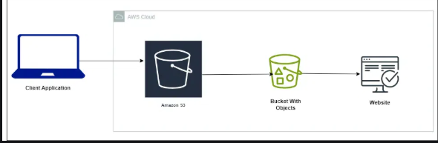

* **Implementation**
* **Sign in to AWS Management Console**

1. Click on the Open Console button, and you will get redirected to AWS Console in a new browser tab.
2. On the AWS sign-in page,
   * Leave the Account ID as default. Never edit/remove the 12-digit Account ID present in the AWS Console. otherwise, you cannot proceed with the lab.
   * Now copy your User Name and Password in the Lab Console to the IAM Username and Password in AWS Console and click on the Sign in button.
   * AWS Region: Select **(MUMBAI) ap-south-1**

## STEP 1: Creating a S3 Bucket

In this task, we are going to create a new S3 bucket in the ap-south-1 region with a unique name disabling ACLs, and allowing public access for hosting the static website.

1. Navigate to **S3** by clicking on the **Services** menu at the top, then click on **S3** in the **Storage** section.
2. In the S3 dashboard, click on the **Create Bucket**

button.

* In the General Configuration, **Bucket name**: Enter **your Desire Bucket Name.**
* **Note:** S3 Bucket names are globally unique, choose an available name. Maybe you can enter your name and create one.

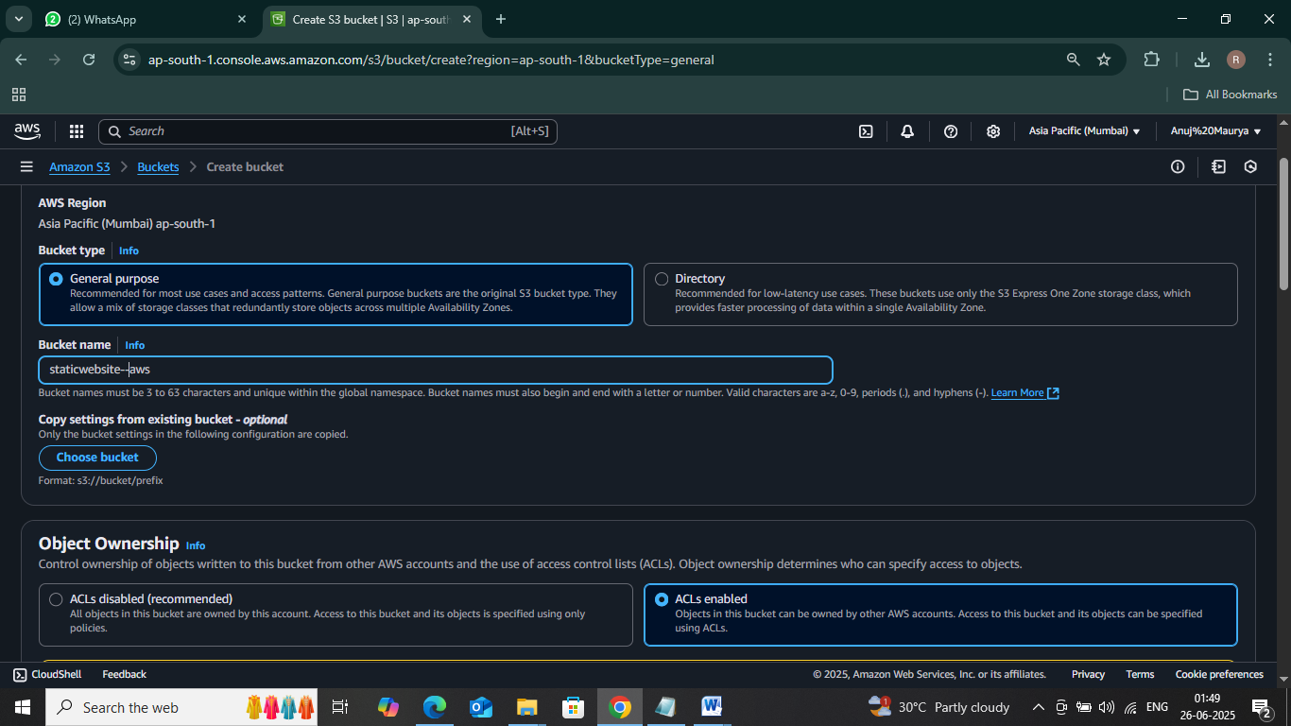

1. Object ownership: Select the **ACLs Enable**
2. In the option of **Block Public Access settings for this bucket**, **Uncheck** the option of **Block all public access**. **Check** the I acknowledge that the current settings might result in this bucket and the objects within becoming public checkboxes

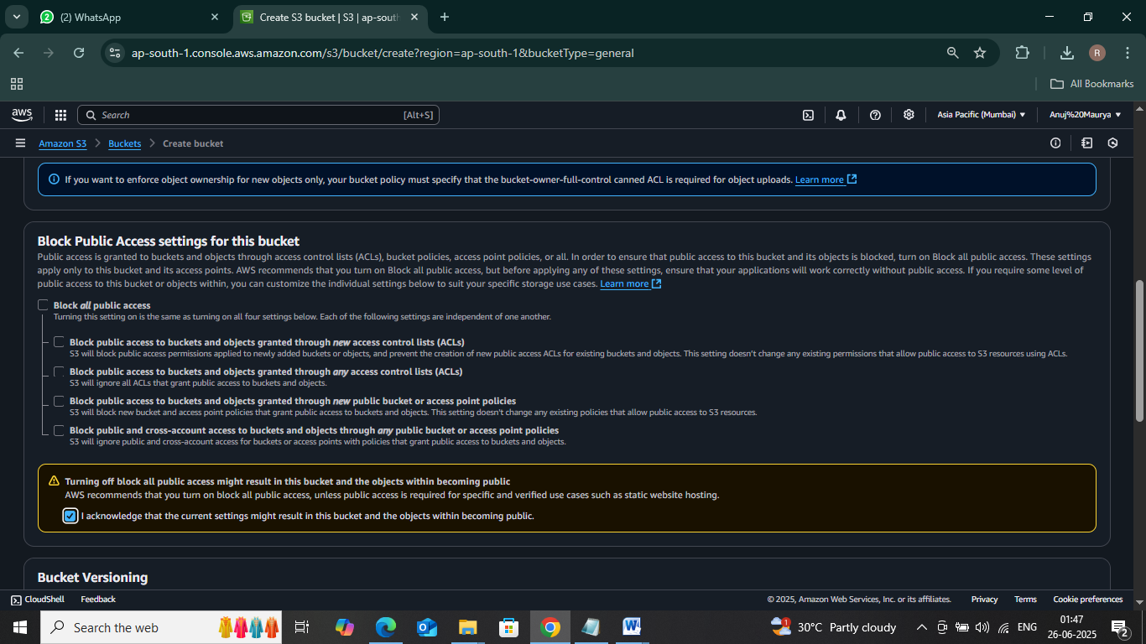

1. Keep everything default and click on the **Create Bucket** button.

Bucket Created Successfully….

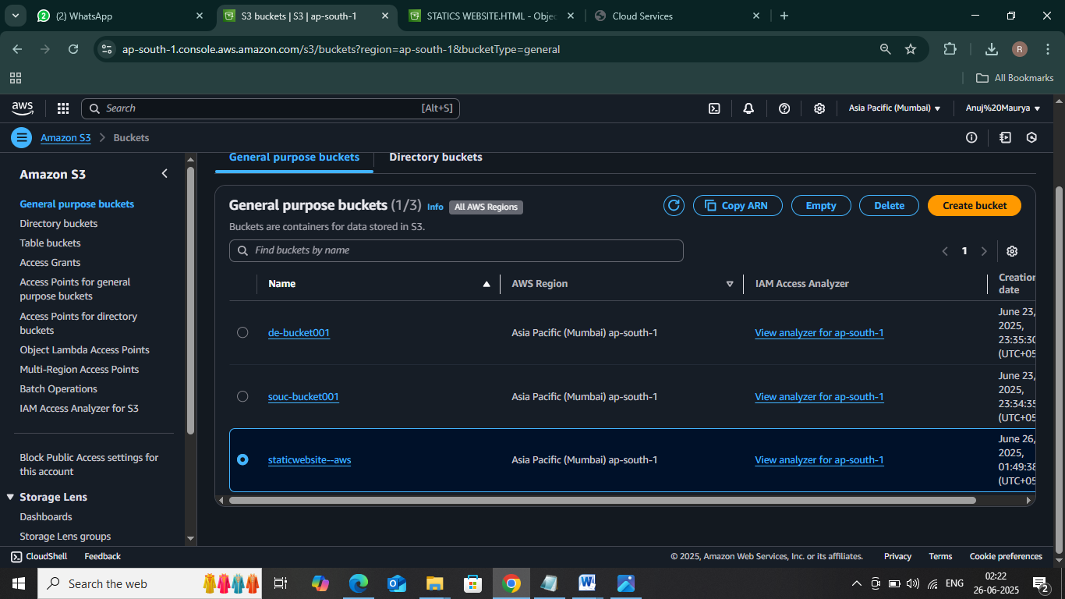

* **STEP 2: Enable Static Website Hosting settings**

In this task, we will enable static website hosting for our S3 bucket, configure it to use index.html and error.html, copy the provided endpoint, upload two files, and configure the bucket policy by copying its ARN and pasting the provided policy code.

* 1. To proceed, go🡪 to the **S3 bucket name** that you created and click on it.
  2. After that, navigate to the **Properties** tab which can be found at the top of the screen.

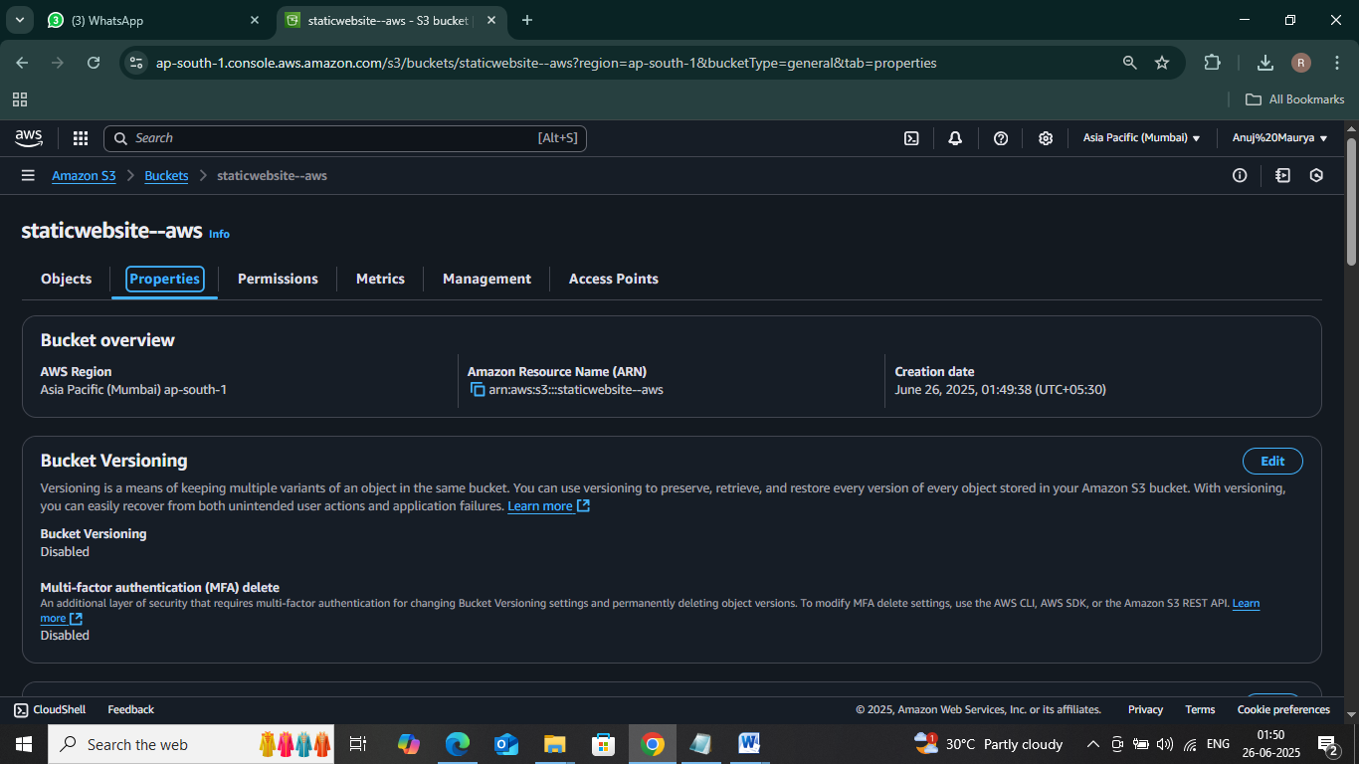

* 1. Scroll down to the **Static website hosting** section and click on the **Edit** button.

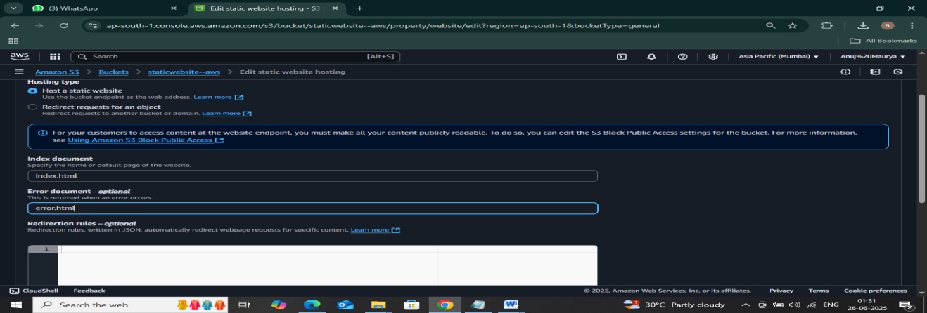

1. In the **Static website hosting** dialog box

# Static website hosting: Select **Enable**

1. Hosting type: Choose **Host a static website**
2. Index document: Type ***index.html***
3. Error document: Type ***error.html***
4. Click on **Save Changes**.

**NEXT>>**

* To configure your S3 bucket, access the **Permissions**

# tab and make the necessary configurations.

* In the **Permissions** tab, Click on the **Edit** button beside the **Bucket Policy**.

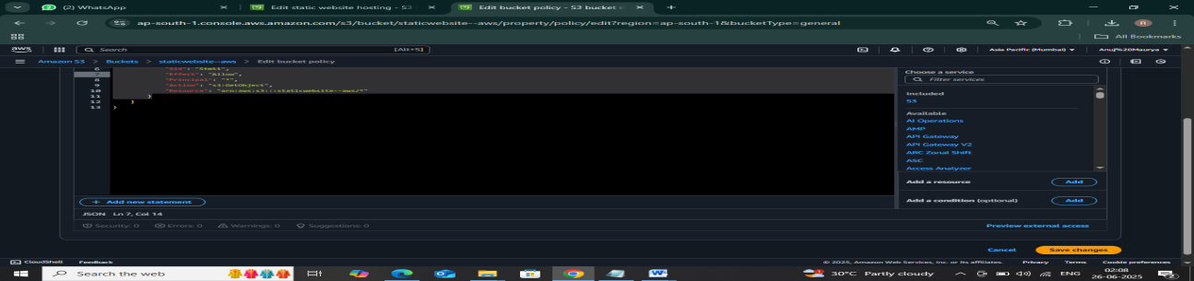

# You will be able to see a Blank policy editor.

* + Before creating the policy, you will need to copy the **ARN** (Amazon Resource Name) of your bucket.
  + Copy the **ARN** of your bucket to the clipboard. It is displayed at the top of the policy editor. it will look like **ARN: “arn:aws:s3:::your-bucket-name**".
  + In the policy below, **Update** the bucket ARN on the Resource key value and **paste** the below policy code in the editor.

{

"Id":"Policy1",

"Version":"2012-10-17",

"Statement":[

{

"Sid":"Stmt1",

"Action":[ "s3:GetObject"

],

"Effect":"Allow",

"Resource":"replace-this-string-with-your-bucket-arn/*",

"Principal":"*"

}

]

}

Click on the **Save Changes** button.

# **Step 3: Uploading Website Content to S3**

* Click on your S3 bucket, click on Upload, then click on **" Add files"**, Select and upload your website files (HTML files).

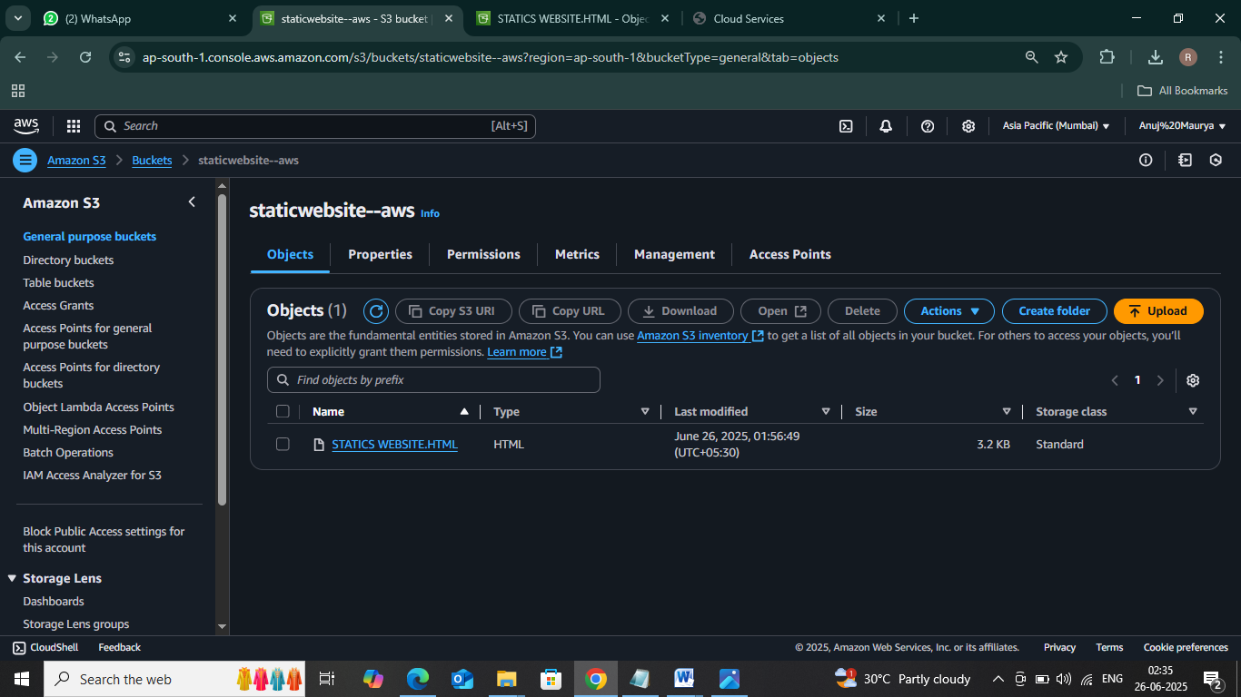

## Test the website

* Now copy the **static website URL**
* Then inside your bucket



* Locate your html file and open it

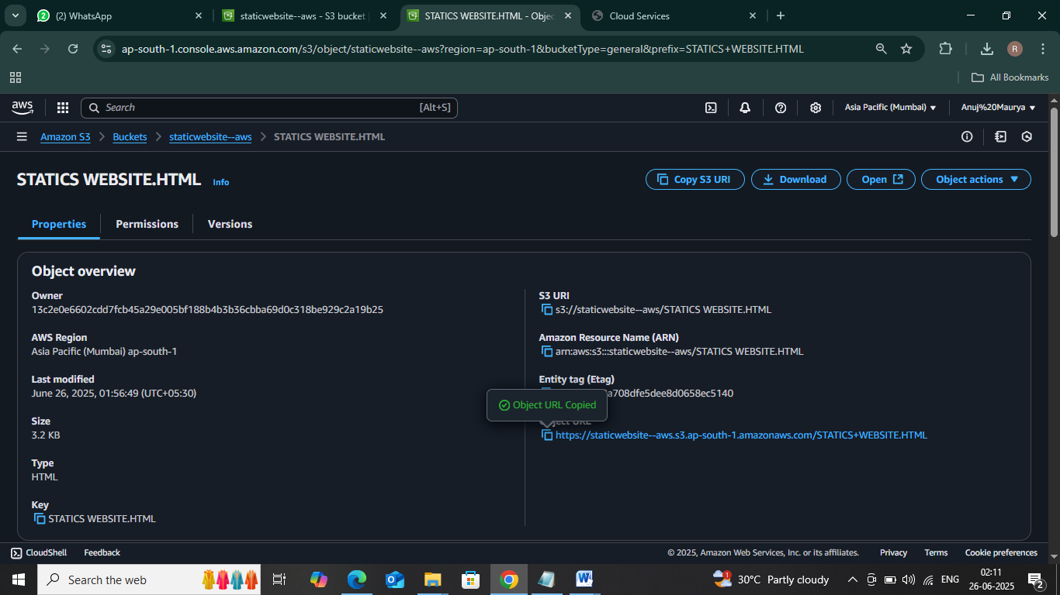

* Then open your html file and copy its object url , and search it in new tab.

* Congratulation YOU can see your WEB Site..

